 May/ June 2024
Dates to remember.  15th June – Shire Clerk Market  3rd July – Member meeting  Christmas in July @ Bag End Studio  20-21st July - BVAC Art Expo |  |  | Message from our President.  Hello Everyone,  What a blast the high tea was, so many people enjoyed themselves. Again, well done to all.  BVAC was a success, and it was great to see the creativity of our members once again. I look forward to catching up soon.
Review of the Mad Hatters tea Party  On May 18th SA truly excelled themselves, by hosting an amazing event at Wynnum Manly Leagues club.  Firstly, I think we should acknowledge the work of the committee and all associated members in showing the community the collective creative ability of our group and what our members can offer to the community.  At set-up, the vibe in the room was electric and  Sharon should be truly commended for her fine project management/event coordinator skills.  I took 140 photos on the day and while I was cursed by many, I think a picture tells a better story of just how amazing the day unfolded.  So, enjoy the photos |  |  | Mad Hatters Pop up Shop  SA members presented an attractive display of their creative talents, and guests enjoyed purchasing our creativity.  Thank you to Wendy and her band of cashiers kept busy on the day.  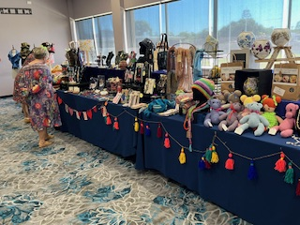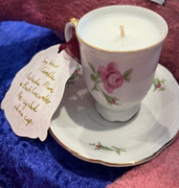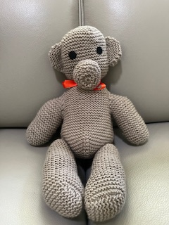  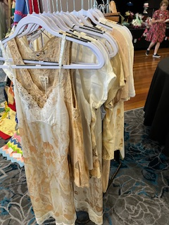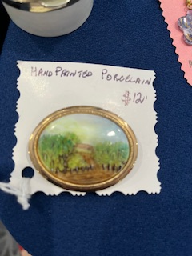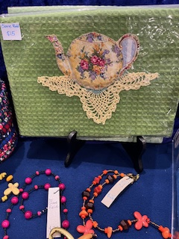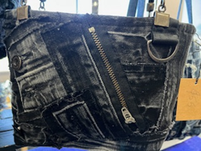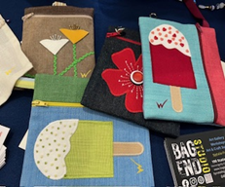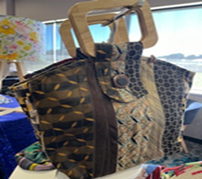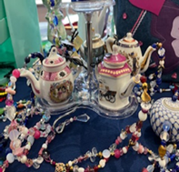  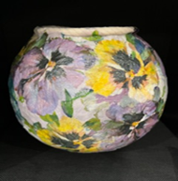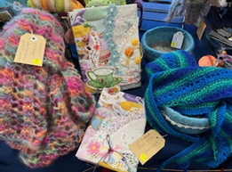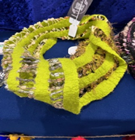  Well done to all our members $1683 in sales
Our Member’s Hats were simply outstanding  Lewis Carroll ‘s character “the Mad Hatter” was known for his colourful eccentric behaviour and that was certainly the case at our tea party.  I’m sure Alice, the Mad Hatter, the Cheshire cat, the March Hare and the White Rabbit would have slotted in very well at our wonderful event.  Members relished in looking very dapper in their highly decorated hats.  All so different, yet all so creative.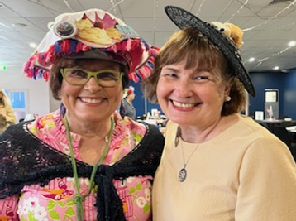 |  | 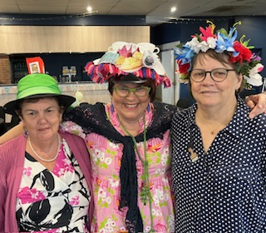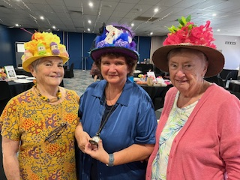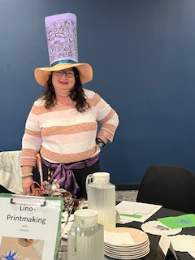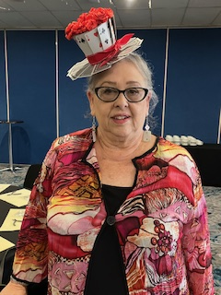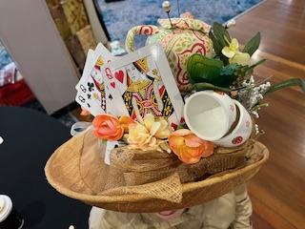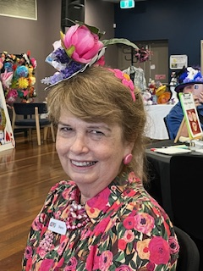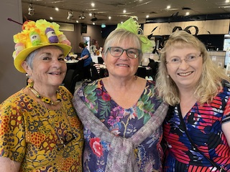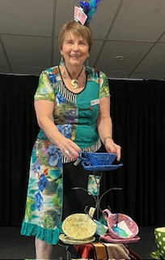
Well done and thanks to all our tutors who donated their time, skills, and materials to make the creative part of the morning a success. |  | 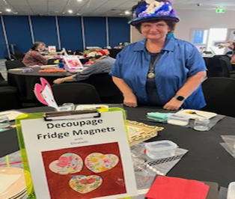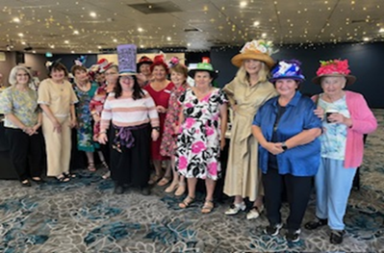  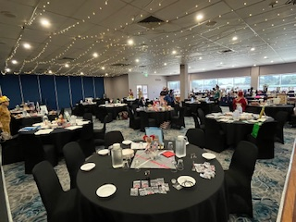
Our guests really embraced the opportunity to dress up and have a bit of fun.  Huge thanks to Sharon for creating the props for the photo shoot area. Our guests loved this area and lots of fun phots were no doubt shared with family and friends.  …. spreading the word that Scattered Arts is a wonderful Community Group.  The raffles were simply beautiful, and we must thank you, our generous members for the donations and time spent wrapping and making the recipients very happy. Thank you to Helen Reid for selling $529 in raffle tickets.  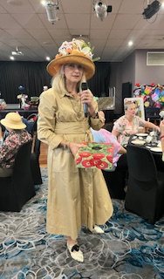  Best hat and most creative costume winners.  And not forgetting the Steam Punk couple looking very dapper and getting a special mention for their creative outfits.  The smiles on the guests’ faces told the story of a fabulous day. |  | 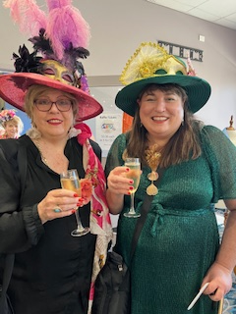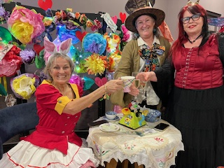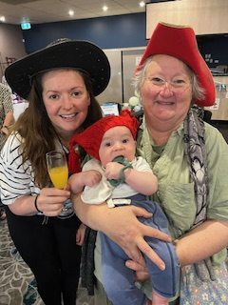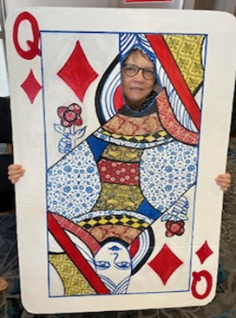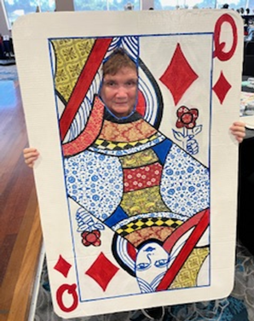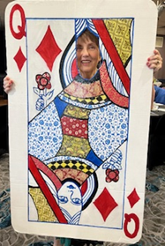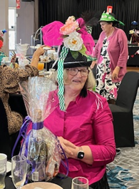  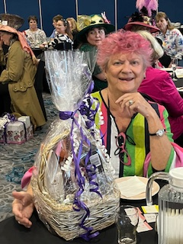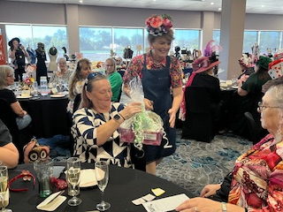  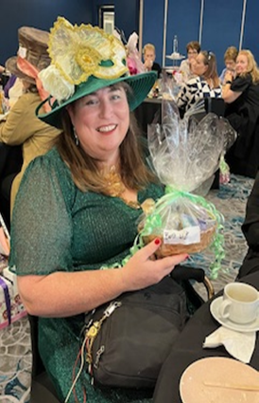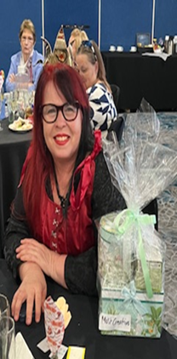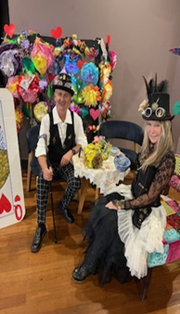
BVAC Pop Up Shop at Mt Cootha Botanical Gardens  7-9th June.  Malissa, Pat, Wendy, Jan, Sharon, Desley, Carolyn and Clare displayed their creative works under the banner of SA.  Members, Michele R (painted ceramics) and Helen Medland (beaded jewellery) also displayed beautiful works of art.  The weather was delightful, and Sharon made many buyers incredibly happy with purchases of lantern kits.  Well done also to Carolyn Turner who sold a solid silver bracelet making one customer very happy.  Thanks to Pat for tallying the sales. Overall SA members sold $1876 over the weekend with Friday being the best sales day with $1008 recorded.  Once again Thanks to Wendy for all the associated organisation of this successful weekend  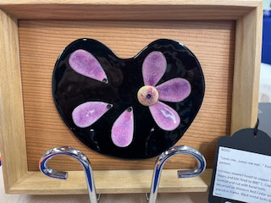  Hop on Facebook and have a look at Judith Scott’s work with silk scarves  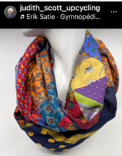 | 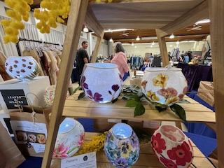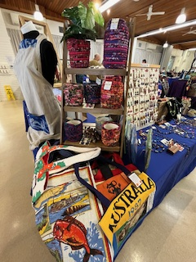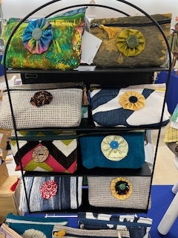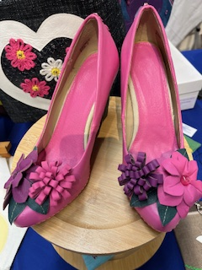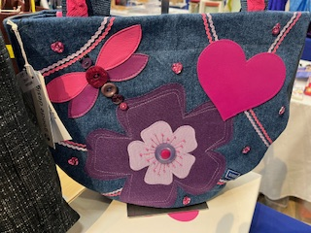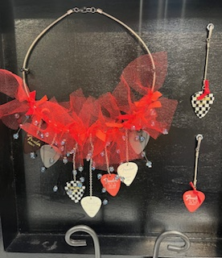  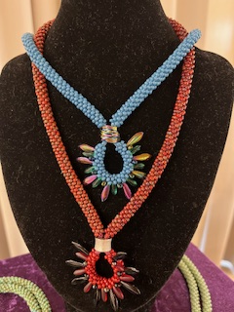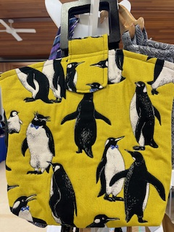  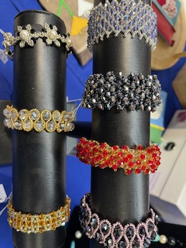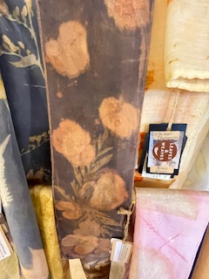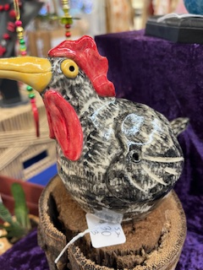  What’s on around the Southeast QLD in July ?  It might be chilly in Warwick but on18-28 July this beautiful country town comes alive. 2024 being its 20th anniversary is sure not to disappoint and it’s a pleasant 2-hour drive.  The Yarntopians create colourful installations around the town.  Look out for Casandra who has been crocheting away ready for the big event and Millie who has been busy sewing and creating.  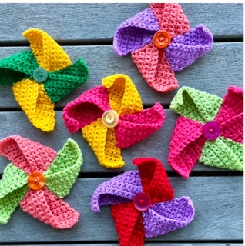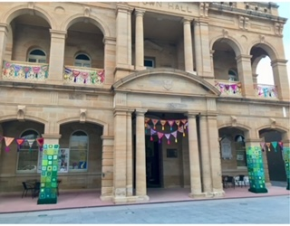
A novel idea to make your creative item more attractive.  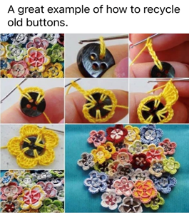 | Quilt and Craft Fair Wednesday – Saturday, 9-12 October  Brisbane Convention Centre 10-4pm  $24 – Adults, Concession Card $20  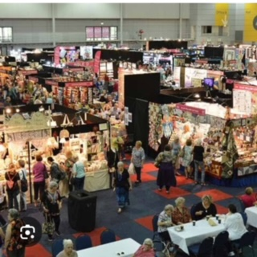
Membership Fees are due on 1 July 2024. Payment can be made by direct deposit to the SA Bank Acct or via the Square at next July Member Meeting. | Christmas in July 3rd  Our member meeting will see us celebrate Christmas !  Please email Sharon to indicate if you can bring a plate of food to share. Thanks to Judy for bringing the Christmas tree.  In addition, could all members bring along a “show and tell” item that they have been working on. We’d love to see your creative talents  

